LAB Logbook

Lab 1
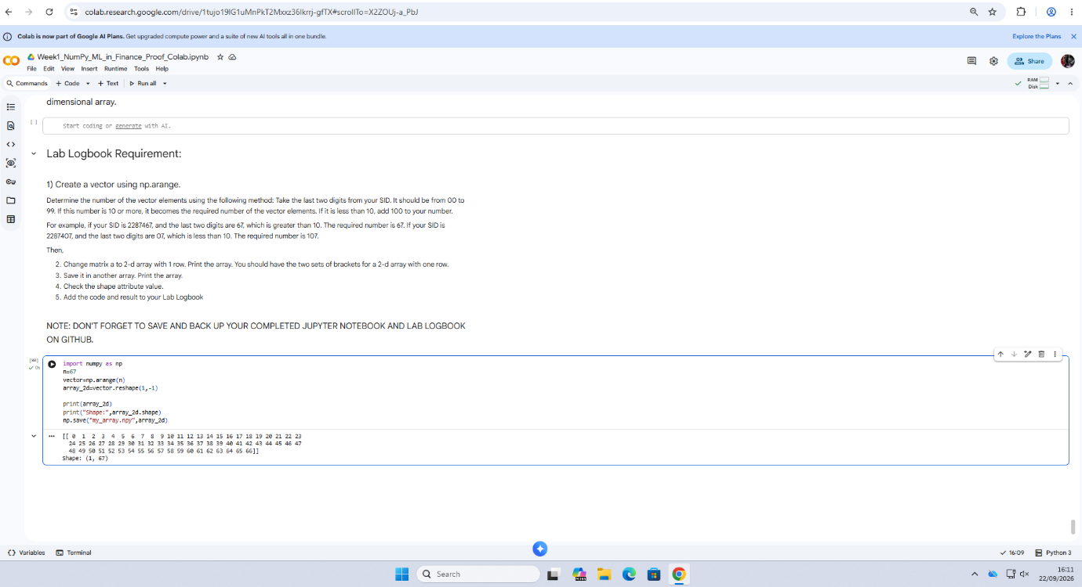
Lab 2
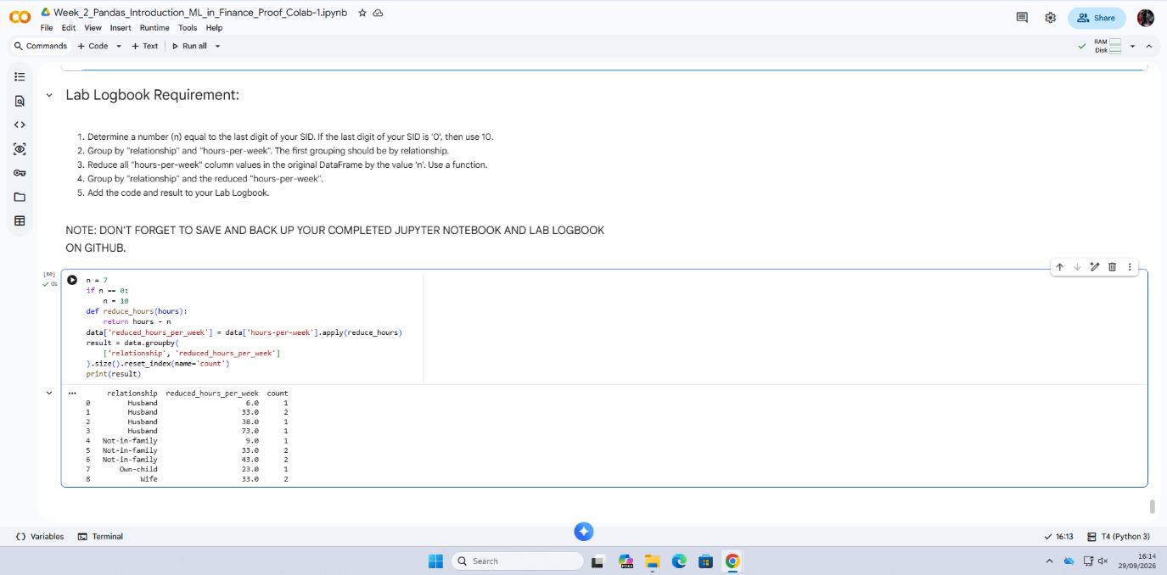

Lab 3
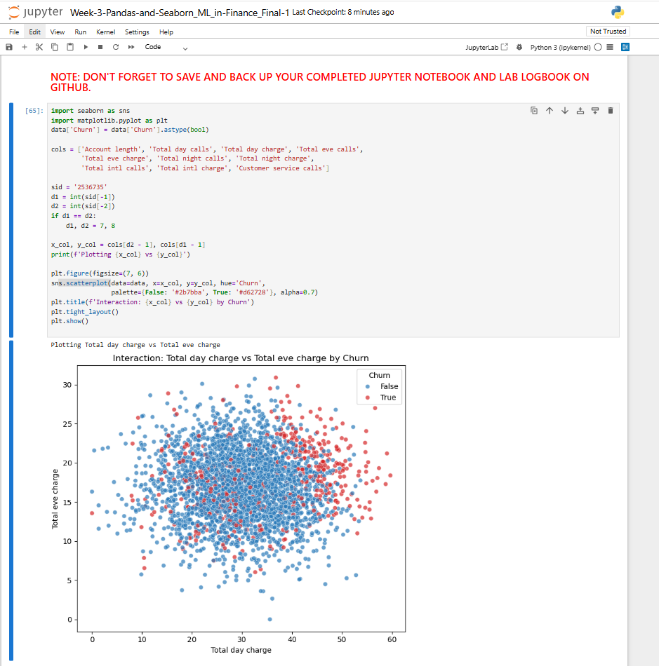

Lab 4
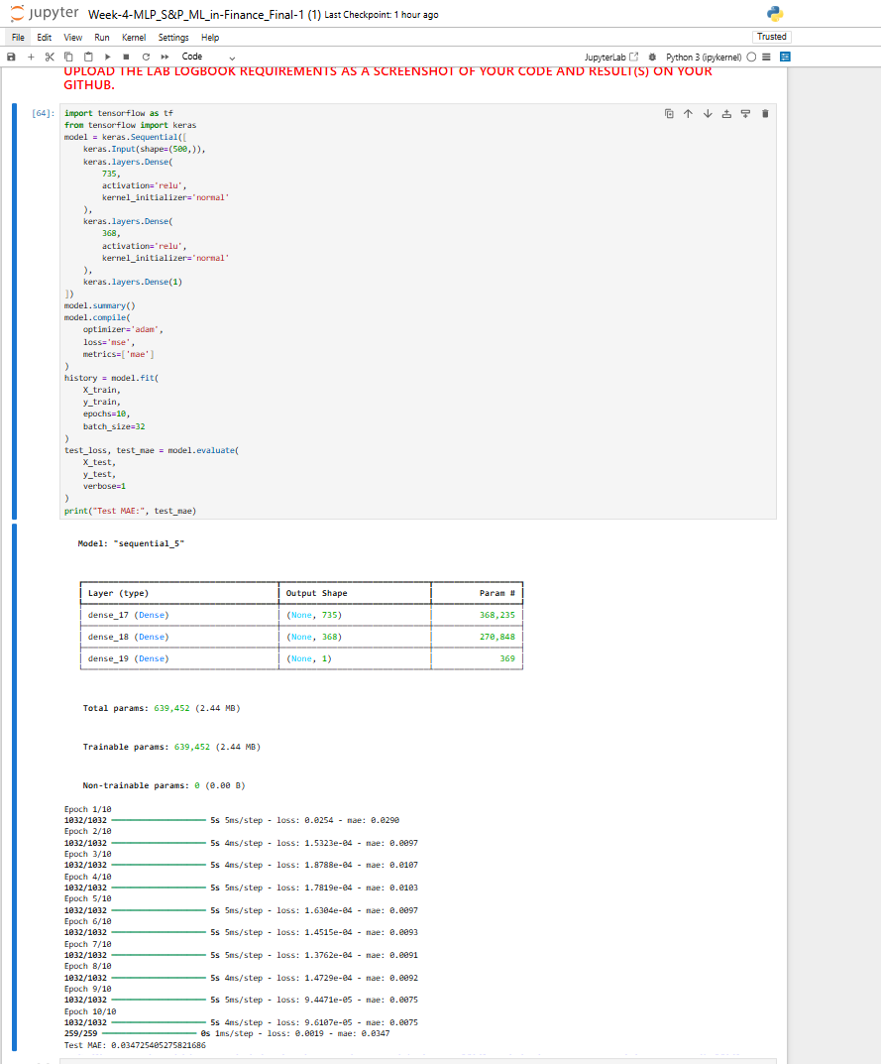

Lab 5
SID-2536735
Z Y = 2 5 3 6 7 3 5.
Z = 3, Y = 5
Neither is 0, so epochs = Z + Y = 8
- CNN Architecture
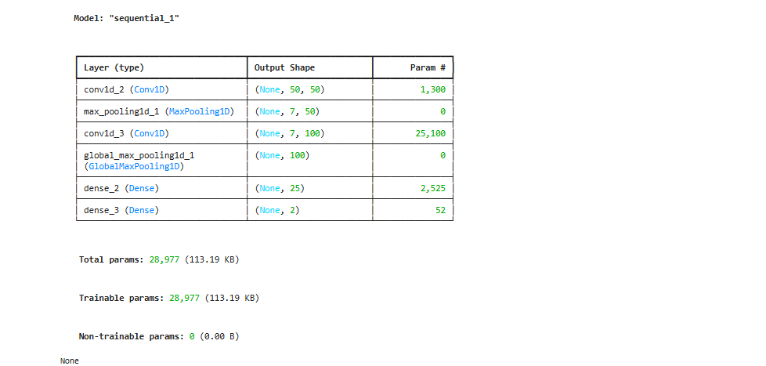
- CNN Training
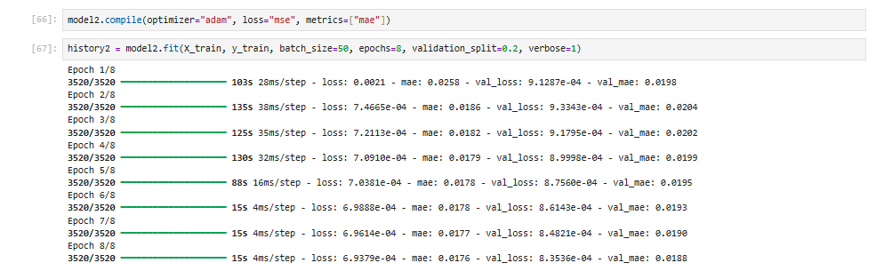
- MAE result

4.MAE Histogram
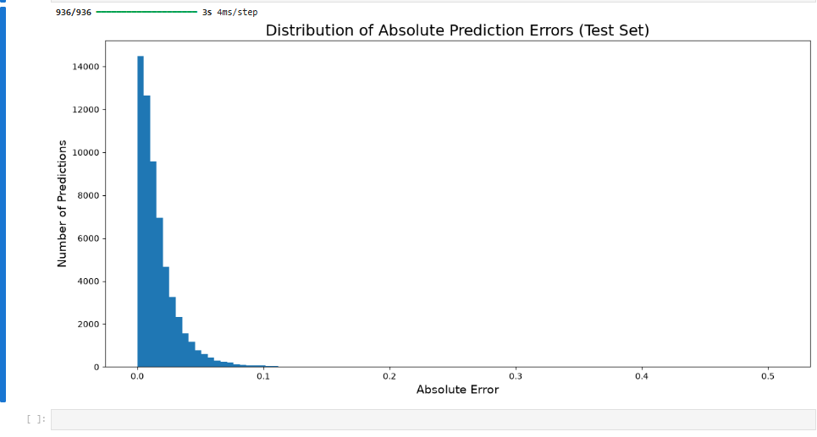

Lab 6
SID: 2536735
Requirement | Calculation | value
Last 5 digits (start point) | 2536735 | 36735
Last 3 digits (time period) | 2536735 | 735
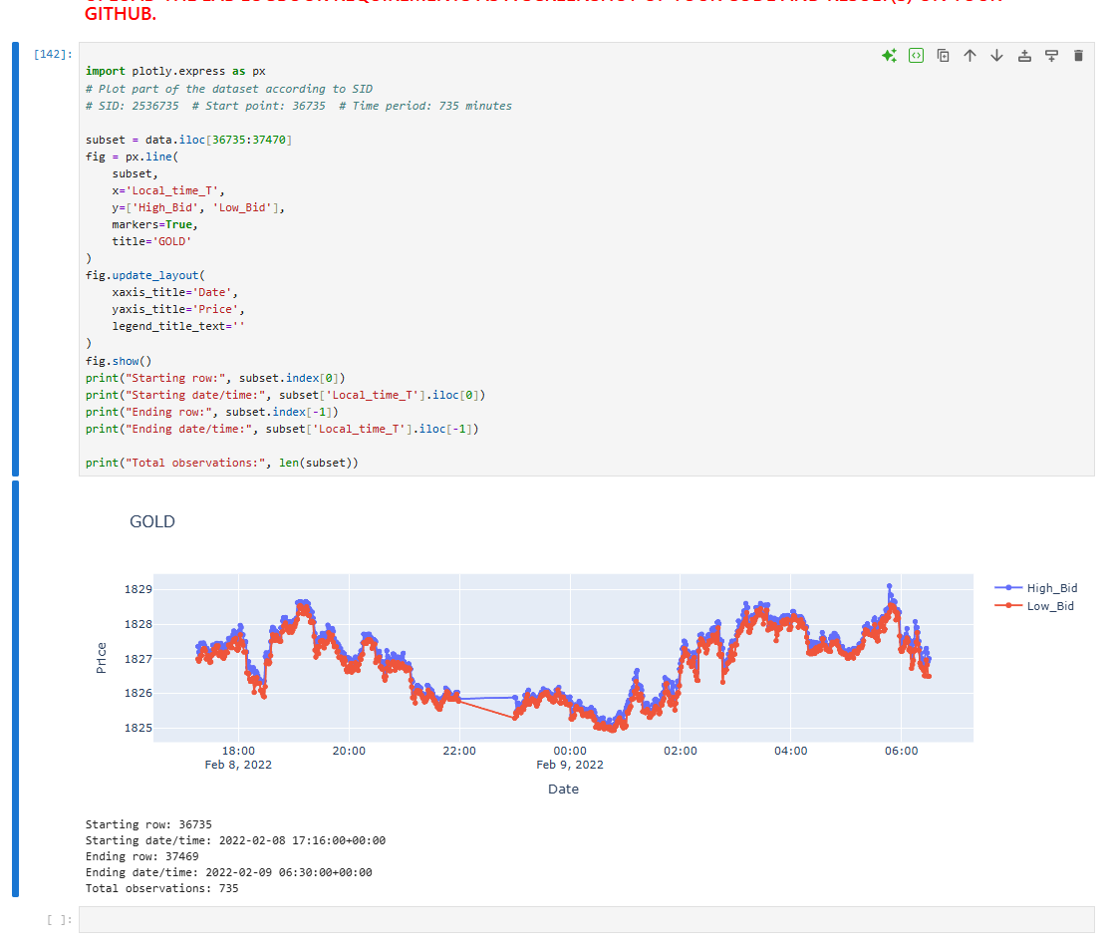

Lab 7
Required LSTM parameter
ZY+10=35+10=45
LSTM units = 45

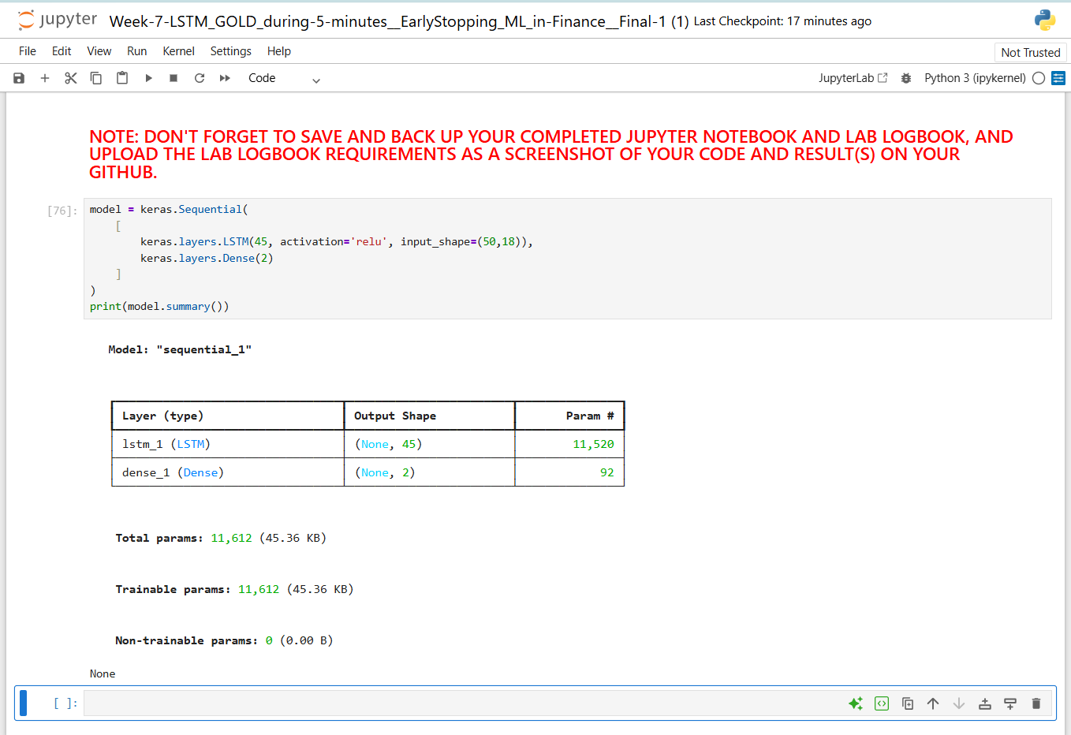

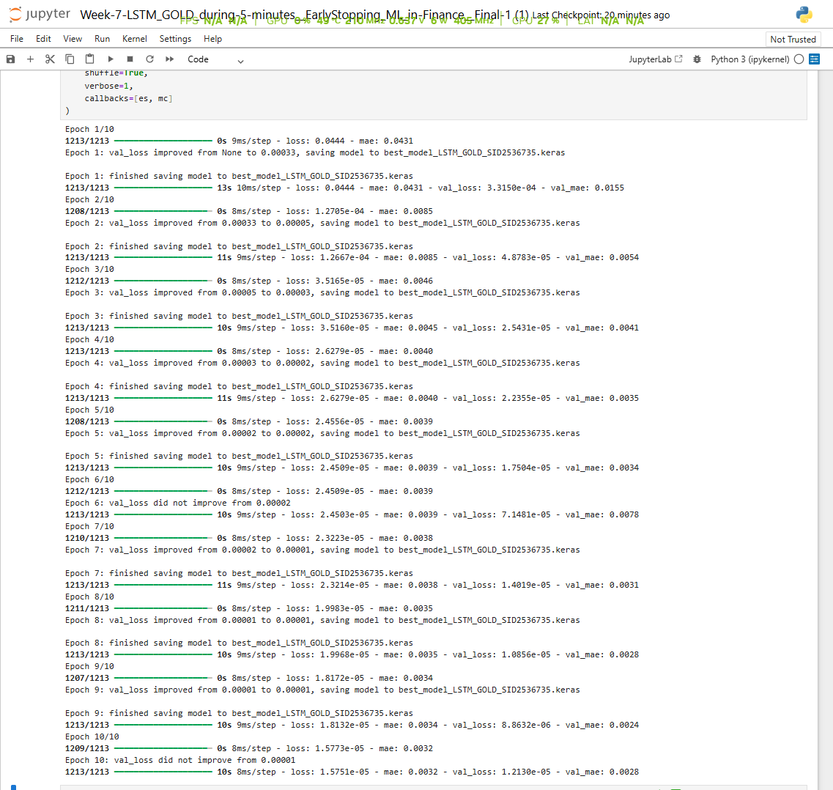

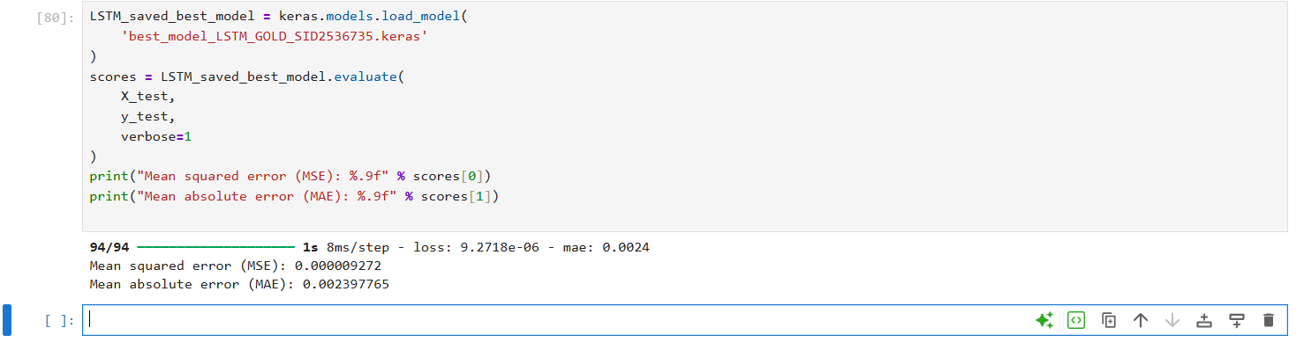

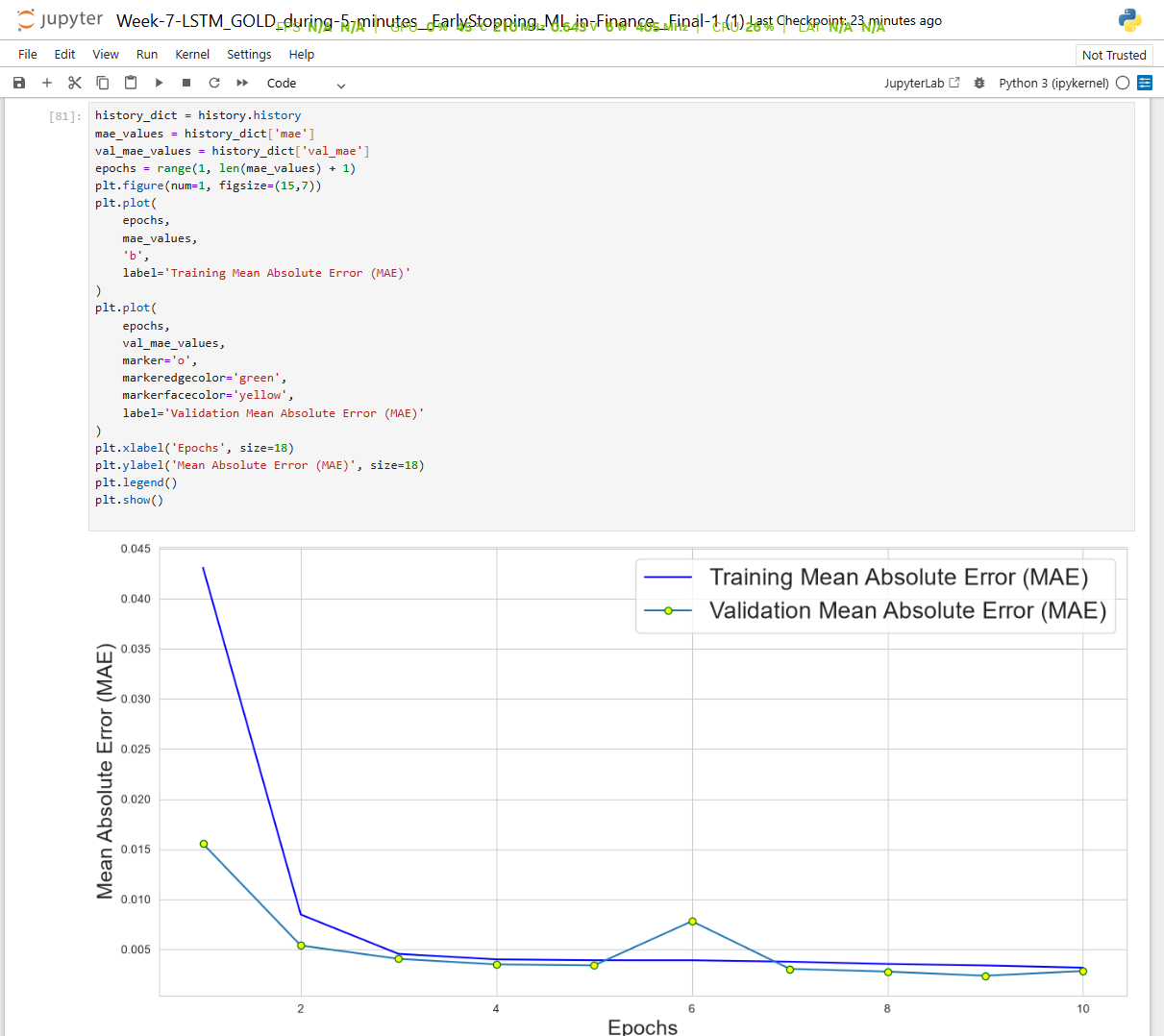

Lab 8 mock
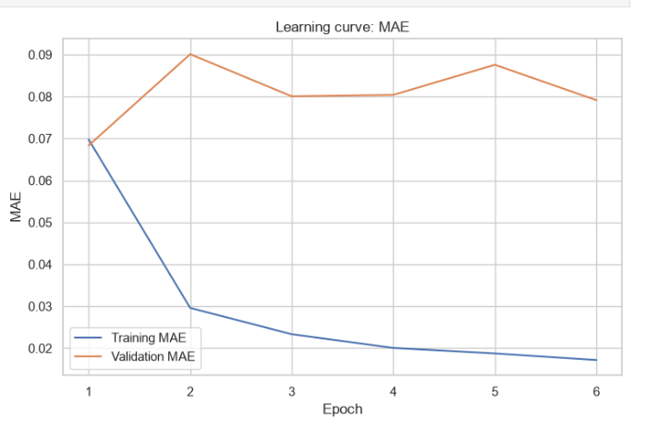
Lab 9

Lab 10

Lab 11

Lab 12

